**Project on S3 Bucket mounting on ec2….**

**Prerequisites required:-**

1. **Create new instance..**
2. **Create s3 bucket..**
3. **Create user and add it to the group with s3fullaccess permission**

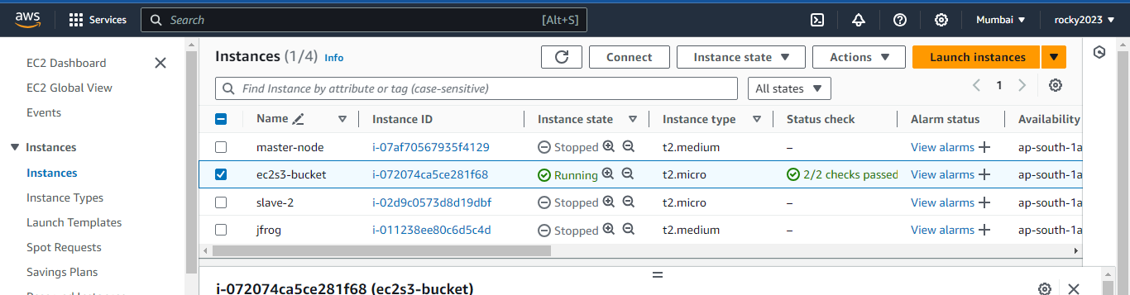

**After launched new ec2instance.. installed the s3fs packages by using below commands..**

1. **Update the package list**

**sudo apt-get update**

1. **Install required dependencies**

**sudo apt-get install -y automake build-essential libfuse-dev libcurl4-openssl-dev libxml2-dev mime-support**

1. **Install additional libraries**

**sudo apt-get install -y pkg-config libssl-dev**

1. **Install s3fs**

**sudo apt-get install -y s3fs**

**2) Created new s3 bucket and uploded some files in that bucket**

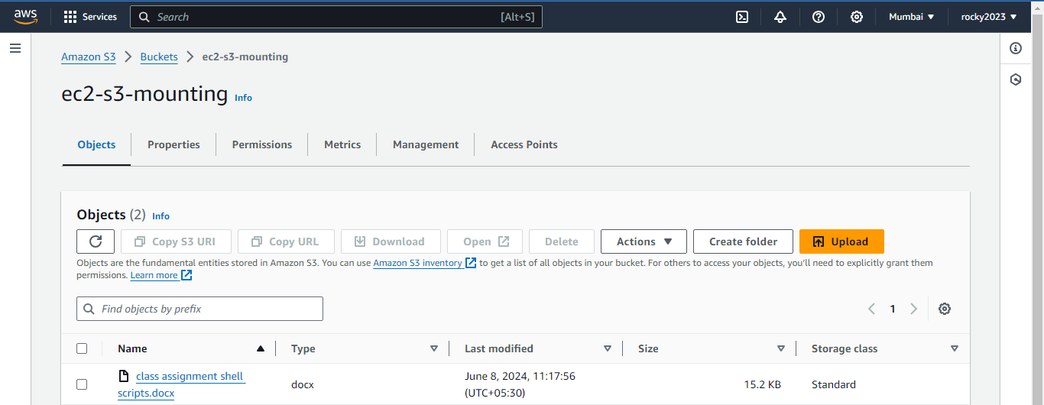

1. **Created user and added in the group and also created accsses keys to configure aws in ec2 terminal…**

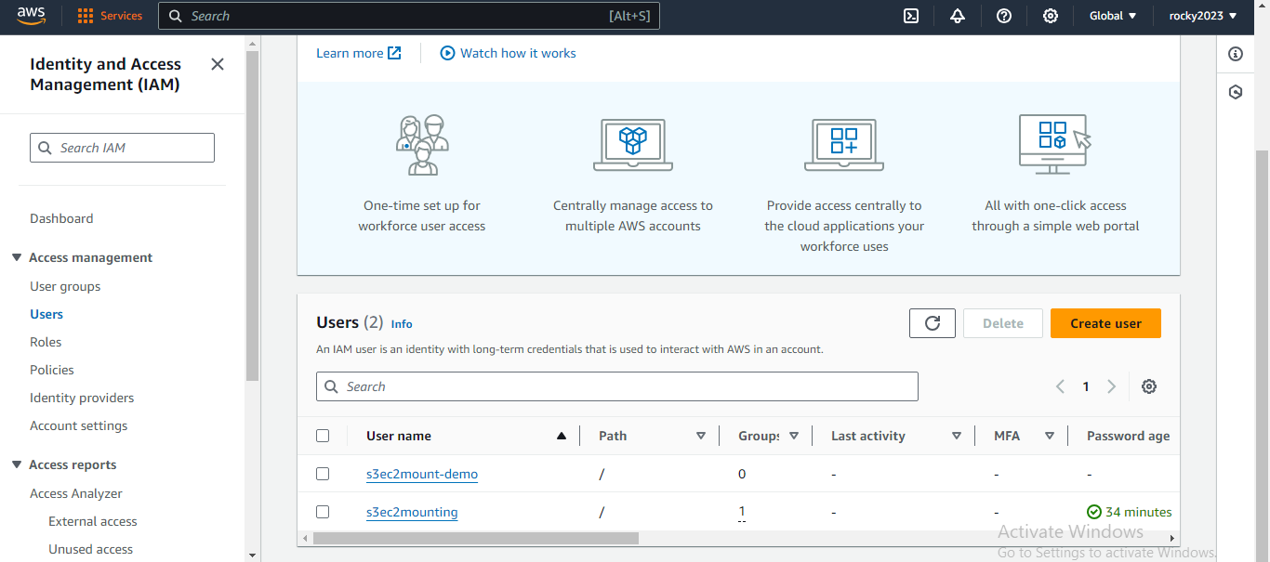

1. **This the access and secret keys to configure aws in ec terminal….**

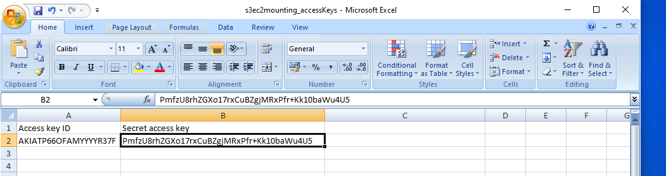

1. **AWS package installed in ec2 by these below shown commands…**
2. **sudo apt-get update**
3. **sudo snap install aws-cli –classic**
4. **aws configure through access and secretkeys above image shown**
5. aws Access Key ID
6. aws Secret Access Key
7. Default region name
8. Default output format
9. Created new directocry for mounting purpose
10. sudo mkdir -p /mnt/mybucket
11. sudo vi /root/password-s3fs
12. in that file I added ACCESS_KEY_ID:SECRET_ACCESS_KEY
13. sudo chmod 600 /root/password-s3fs
14. sudo s3fs mybucket /mnt/mybucket -o passwd_file=/root/password-s3fs
15. below image shows mounted to s3 bucket

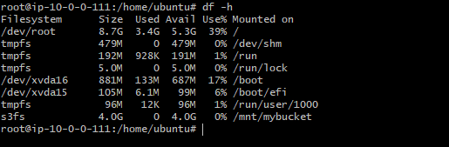

1. Here below index.txt file copied to s3bucket

a) aws s3 cp index.txt s3://ec2-s3-mounting/

C:\Users\rakesh\Desktop\tomcat.sh\moutning s3bucket to ec2\s3 7.PNG

b) Below image shown that file copied from ec2-terminal to aws s3-bucket….

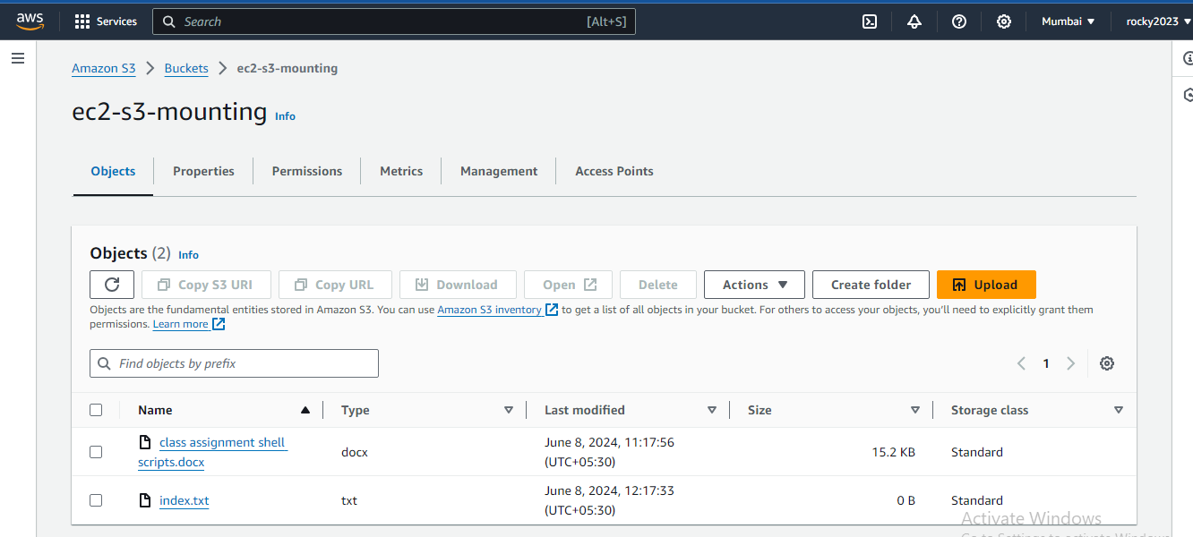

c) And also in s3-bucket uploaded file copied from aws s3-bucket to ec2-terminal..

C:\Users\rakesh\Desktop\tomcat.sh\moutning s3bucket to ec2\s3 9.PNG

That class assignment shell script file copied from this command

**aws s3 cp "s3://ec2-s3-mounting/class assignment shell scripts.docx" "./class assignment shell scripts.docx"**